# 1. SAP RAP Project

## 1.1 Get Service Key

<https://account.hanatrial.ondemand.com/trial/#/globalaccount/67ee94cd-63cb-44a8-9fa9-6fb5cab062f1/boosters>

Click en “Start” y nos despliega la popup para bajar el “Service Key” requerido mas adelante para conectarnos a la cuenta BTP

## 1.2 Conect Eclipse with Account BTP

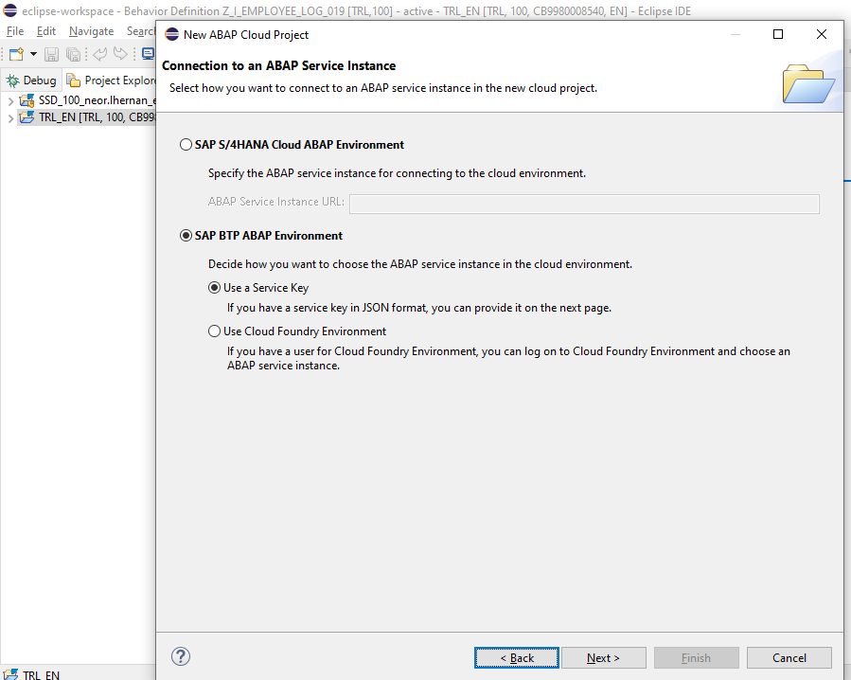

Importamos el archivo del “Service Key” que habíamos bajado en el paso de preparar una cuenta ABAP Trial

La conexión fue satisfactoria y se despliega la ventana para habilitar el Logon, Click en “Copy Logon URL to Clipboard” y lo pego en el explorador.

## 1.3 Create Project ZPRAP_YC

Se ha creado el proyecto ABAP CLOUD ZPRAP_YC

## 1.4 Create Package ZRAP_YC

El paquete ha sido creado

## 1.5 Link AbapGit Repository

Se crea nuevo repositorio para el proyecto RAP SAP

Se hace conexión en eclipse con el nuevo repositorio

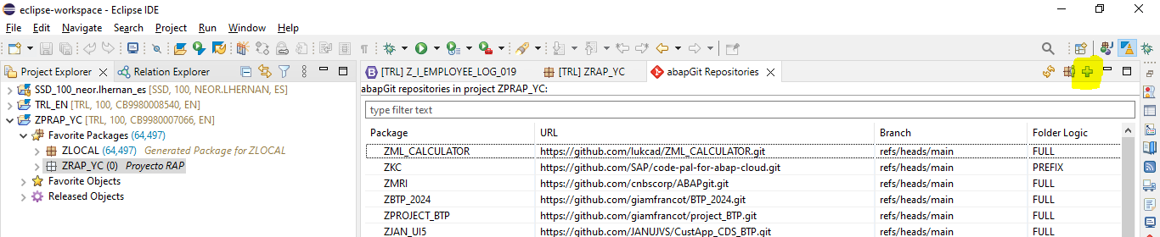

Repositorio Git:

<https://github.com/Yeicorr/ZPRAP_YC.git>

Se ha agregado el link del repositorio y se hace el respaldo con click en “Stage and Push”

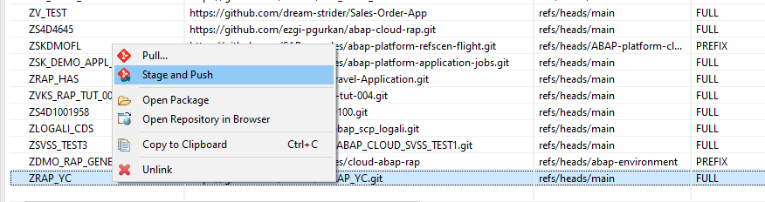

Se identifican los cambios en el repositorio

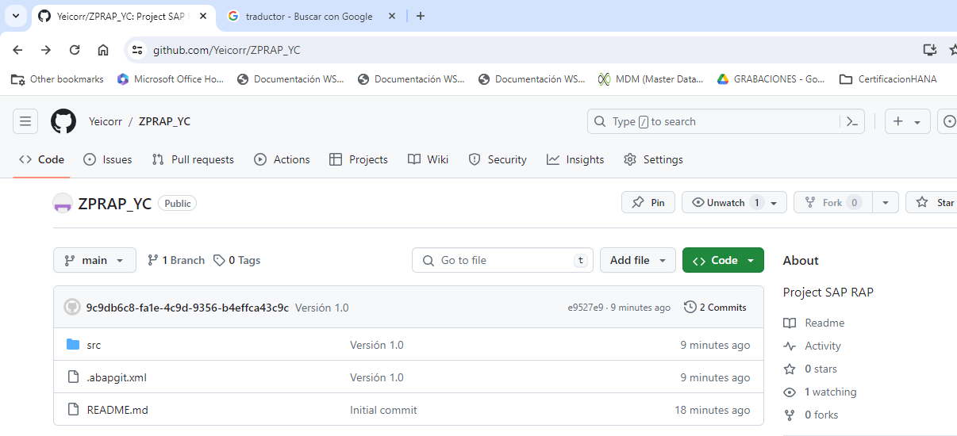

## 1.6 Modelo de Datos

### 1.6.1 Dominios

#### Dominio Id Orden

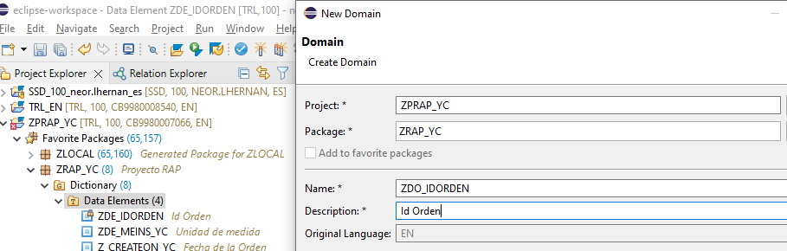

#### Dominio para la fecha

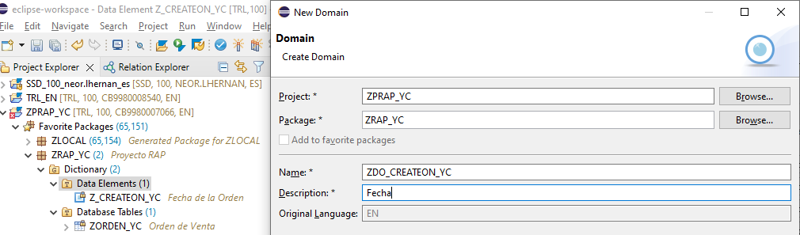

#### Dominio para la unidad de medida

### 1.6.2 Elementos de datos

Se crean los elementos de datos requeridos para el modelo

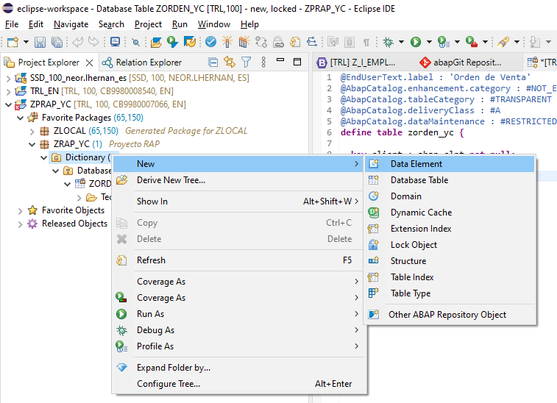

#### Id de Orden

#### Fecha de la orden

#### Fecha de Entrega de la orden

#### Unidad de Medida

### 1.6.3 Tablas

Creamos las tablas requeridas para el modelo

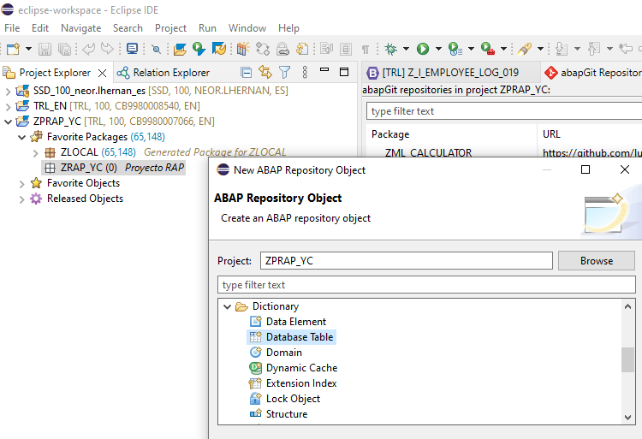

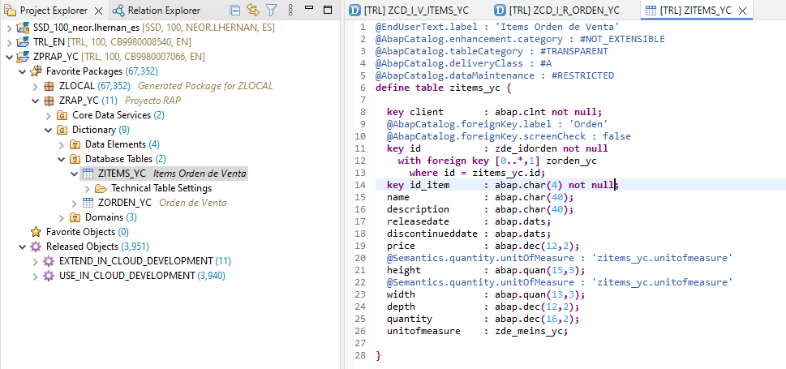

## 1.7 CDS – Core Data Services

### 1.7.1 Data Definition

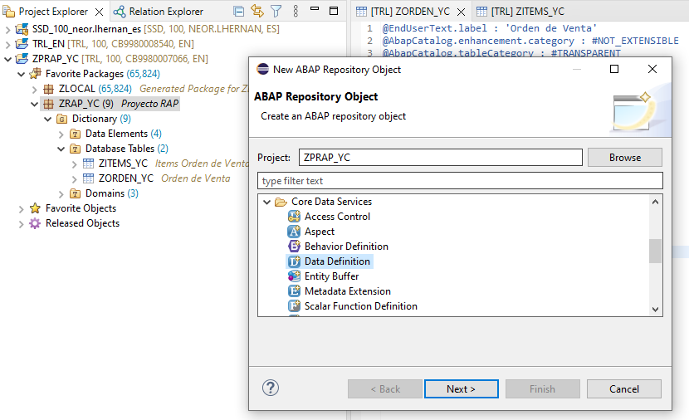

#### 1.7.1.1 CDS View Root Orden

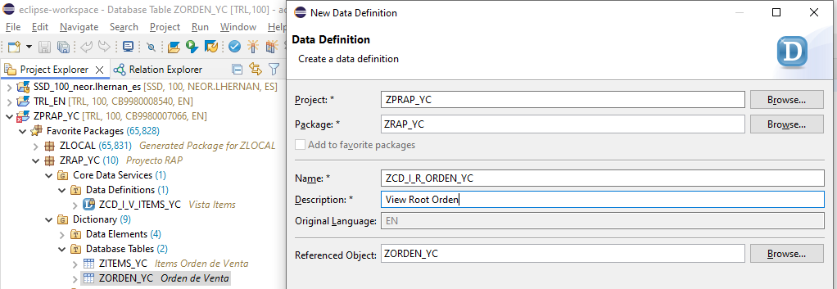

#### 1.7.1.2 CDS View Items Orden

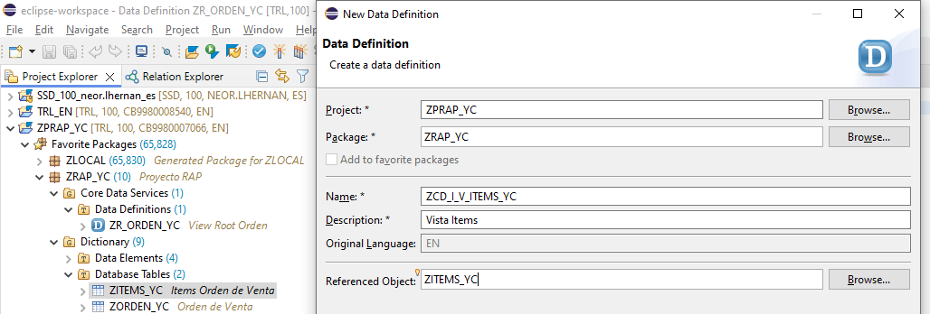

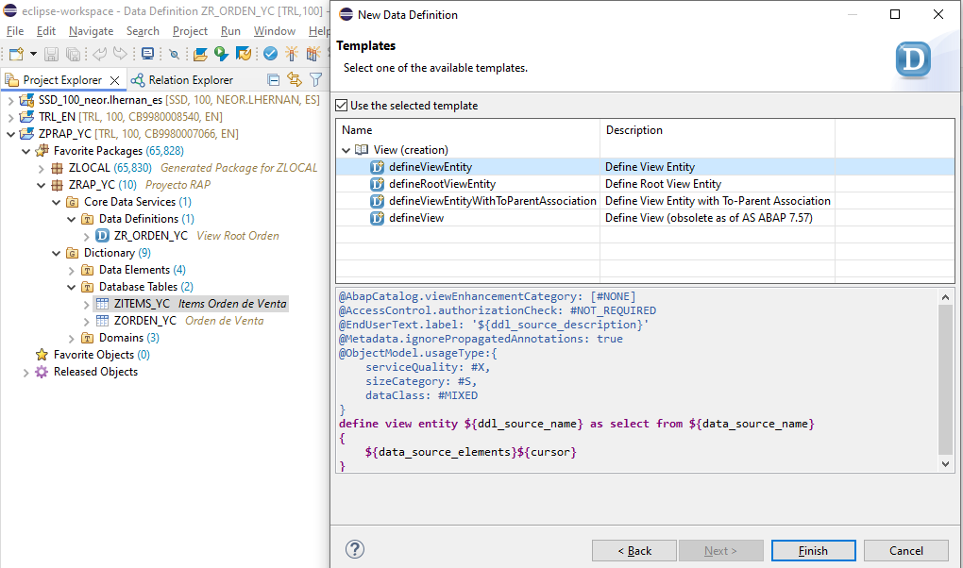

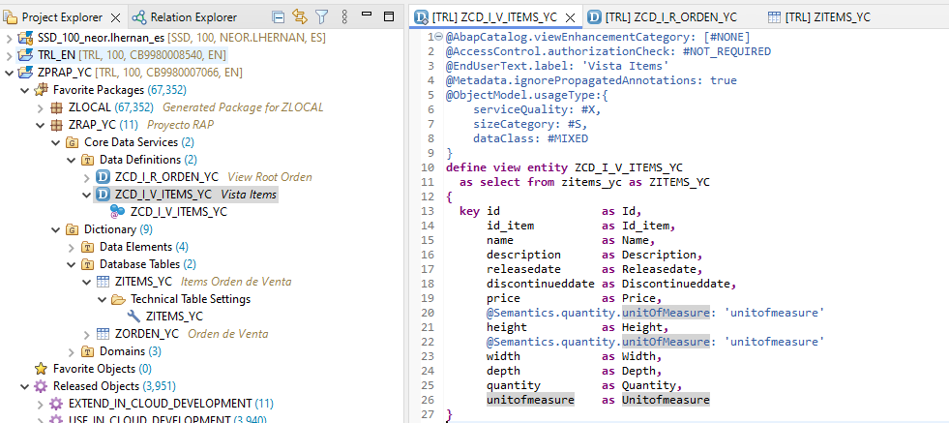

### 1.7.2 Composition / association

#### 1.7.2.1 CDS View Root Orden (Composition)

#### 1.7.2.2 CDS View Items (Association)

## 1.7.3 Projection Root/View

### 1.7.3.1 Projection Root

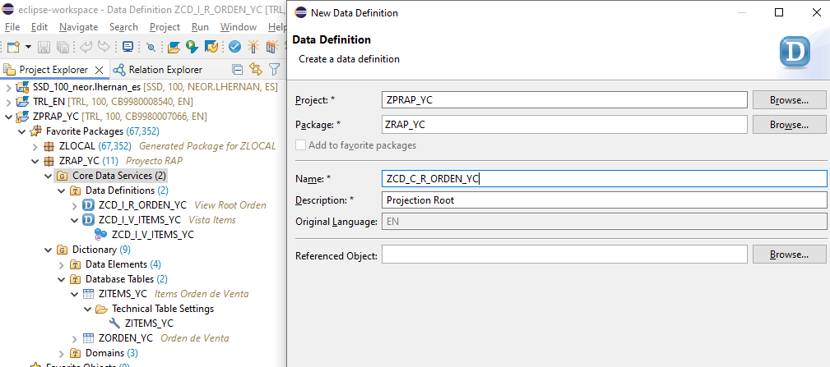

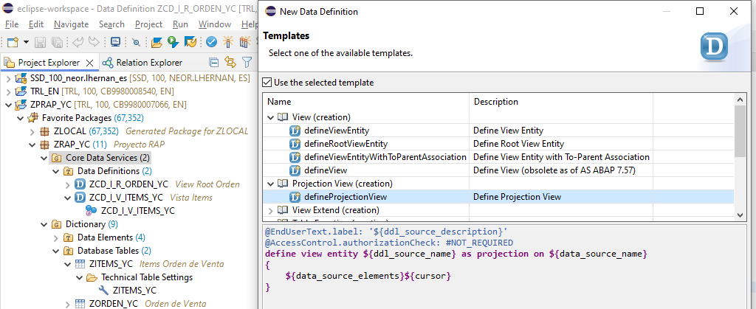

### 1.7.3.2 Projection View

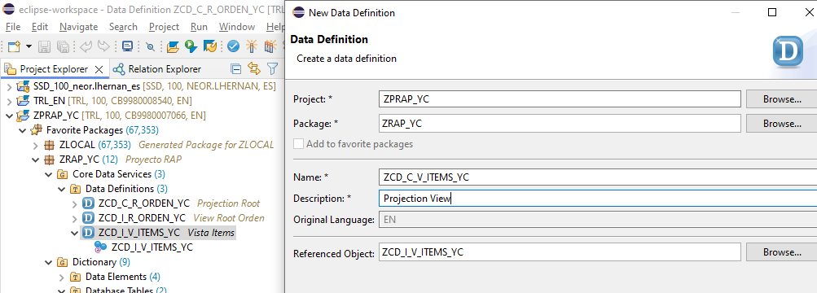

### 1.7.3.3 Projection Root Approval

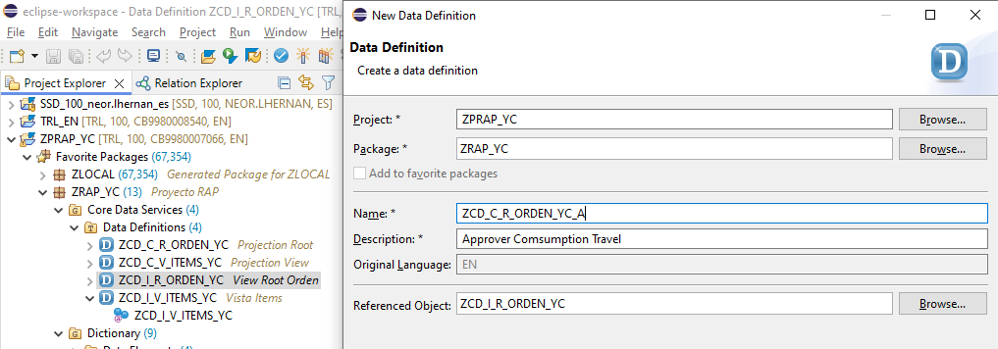

### 1.7.3.4 Projection Root Approval Items

### 1.3.4.5 Redirected – Parent / Composition

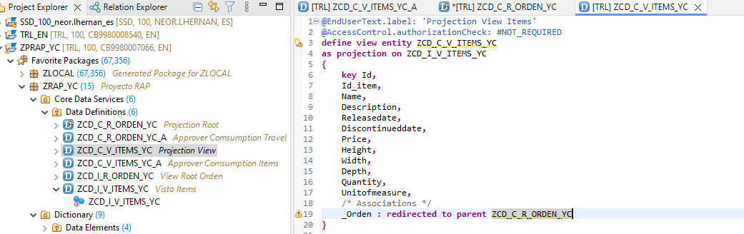

## 1.8 Metadata Extension

Se agrega anotación @Metadata.allowExtensions: true en las projection view creadas

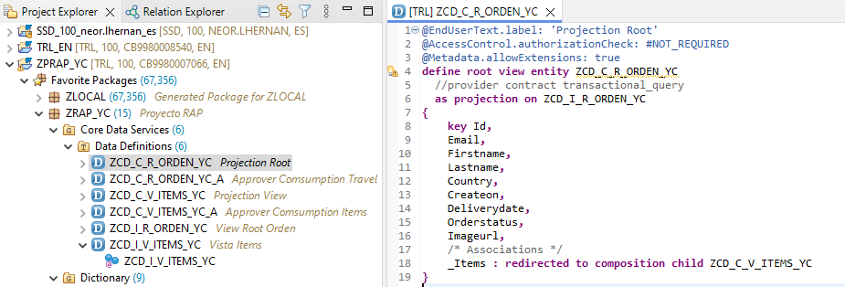

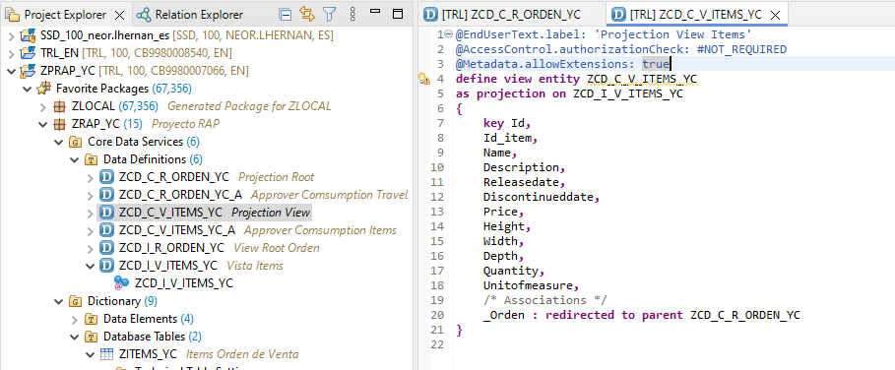

Creamos los archivos de “Metadata Extension” sobre las projection view

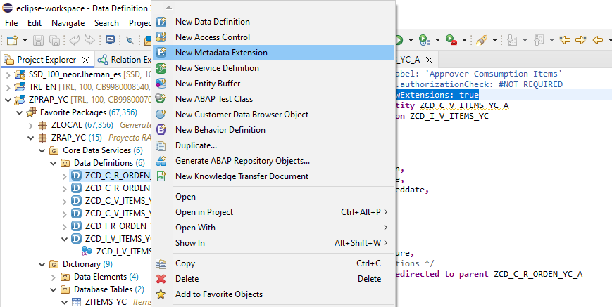

### 1.8.1 Metadata Projection Root

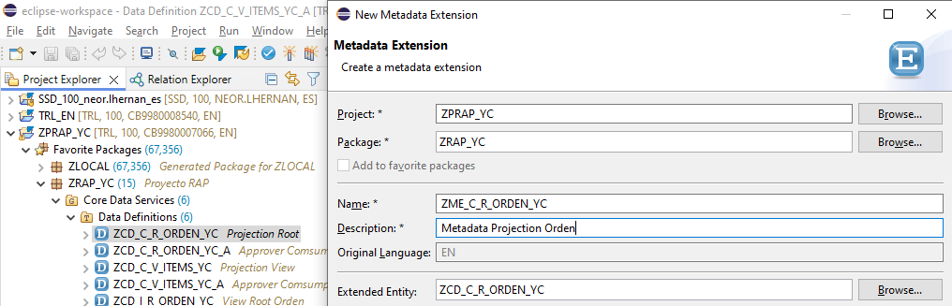

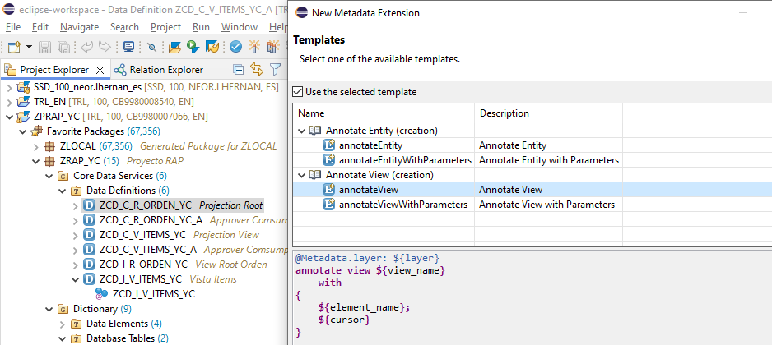

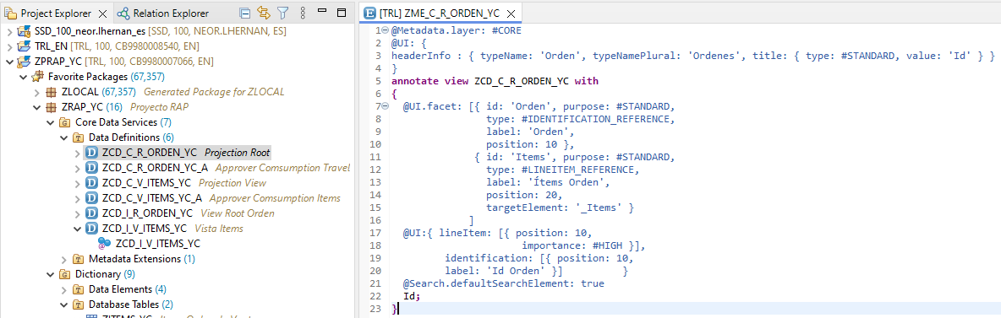

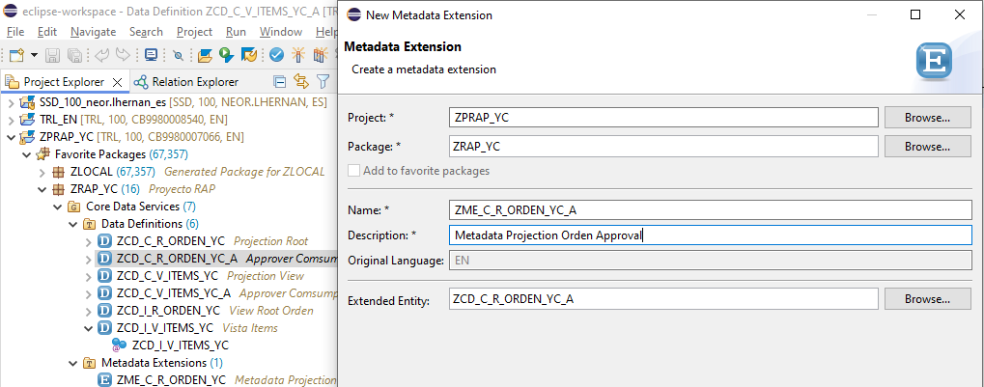

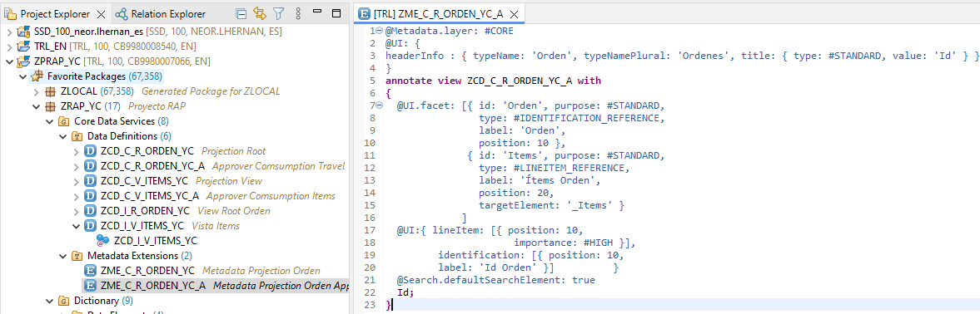

### 1.8.2 Metadata Projection View

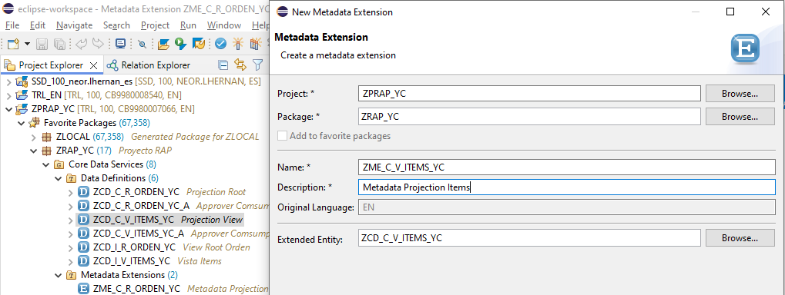

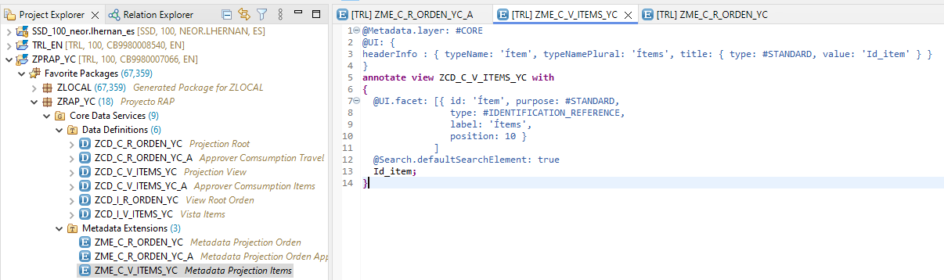

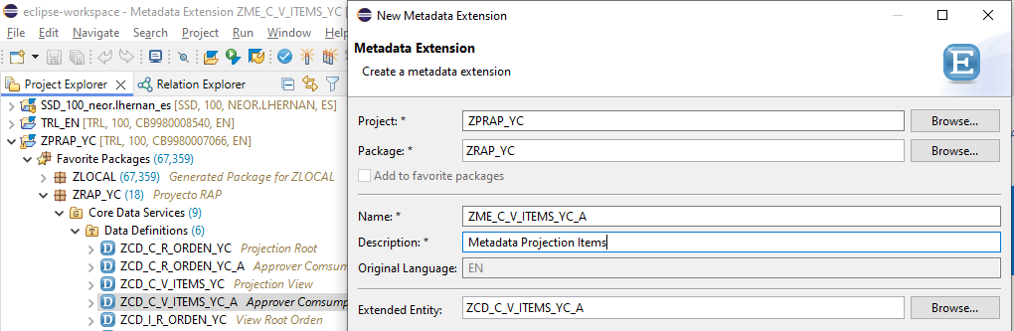

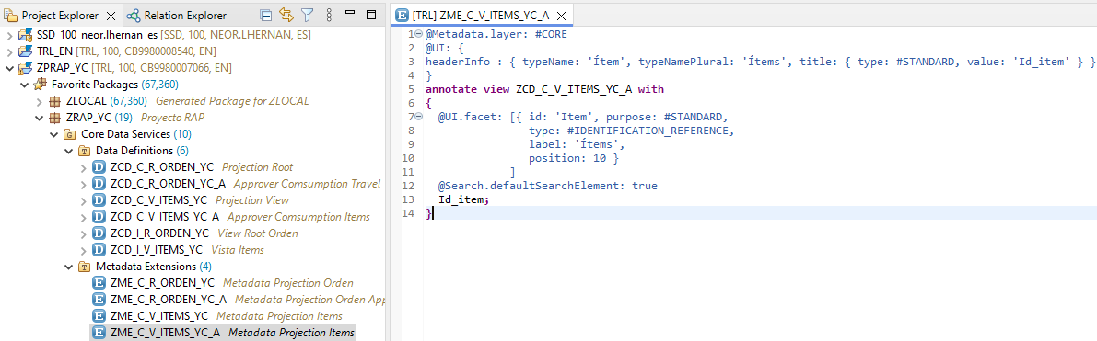

## 1.9 UI

Anotaciones UI en los metadata extensions de las projection view.

### 1.9.1 Metadata Projection Root ZME_C_R_ORDEN_YC

@Metadata.layer: #CORE

@UI: {

headerInfo : { typeName: 'Orden', typeNamePlural: 'Ordenes', title: { type: #STANDARD, value: 'Id' } }

}

**annotate** **view** ZCD_C_R_ORDEN_YC **with**

**{**

@UI.facet: [{ id: 'Orden', purpose: #STANDARD,

type: #IDENTIFICATION_REFERENCE,

label: 'Orden',

position: 10 },

{ id: 'Items', purpose: #STANDARD,

type: #LINEITEM_REFERENCE,

label: 'Ítems Orden',

position: 20,

targetElement: '_Items' }

]

@UI:{ lineItem: [{ position: 10,

importance: #HIGH }],

identification: [{ position: 10,

label: 'Id Orden' }] }

@Search.defaultSearchElement: true

Id**;**

@UI: {

lineItem: [ { position: 20, importance: #HIGH } ],

identification: [ { position: 20 } ] }

Email**;**

@UI: {

lineItem: [ { position: 30, importance: #HIGH } ],

identification: [ { position: 30 } ] }

Firstname**;**

@UI: {

lineItem: [ { position: 40, importance: #HIGH } ],

identification: [ { position: 40 } ] }

Lastname**;**

@UI: {

lineItem: [ { position: 50, importance: #HIGH } ],

identification: [ { position: 50 } ] }

Country**;**

@UI: {

lineItem: [ { position: 60, importance: #MEDIUM } ],

identification: [ { position: 60 } ] }

Createon**;**

@UI: {

lineItem: [ { position: 70, importance: #HIGH } ],

identification: [ { position: 70 } ] }

Deliverydate**;**

@UI: {

lineItem: [ { position: 80, importance: #HIGH },

{ type: #FOR_ACTION, dataAction: 'createOrder', label: 'Create Order' } ],

identification: [ { position: 80, label: 'Status [O(Open)|A(Accepted)|X(refused)]' } ] }

Orderstatus**;**

@UI.hidden: true

Imageurl**;**

/* Associations */

// _Items;

**}**

### 1.9.2 Metadata Projection Root ZME_C_R_ORDEN_YC_A

@Metadata.layer: #CORE

@UI: {

headerInfo : { typeName: 'Orden', typeNamePlural: 'Ordenes', title: { type: #STANDARD, value: 'Id' } }

}

**annotate** **view** ZCD_C_R_ORDEN_YC_A **with**

**{**

@UI.facet: [{ id: 'Orden', purpose: #STANDARD,

type: #IDENTIFICATION_REFERENCE,

label: 'Orden',

position: 10 },

{ id: 'Items', purpose: #STANDARD,

type: #LINEITEM_REFERENCE,

label: 'Ítems Orden',

position: 20,

targetElement: '_Items' }

]

@UI:{ lineItem: [{ position: 10,

importance: #HIGH }],

identification: [{ position: 10,

label: 'Id Orden' }] }

@Search.defaultSearchElement: true

Id**;**

@UI: {

lineItem: [ { position: 20, importance: #HIGH } ],

identification:[ { position: 20 } ] }

Email**;**

@UI: {

lineItem: [ { position: 30, importance: #MEDIUM } ],

identification:[ { position: 30 } ] }

Firstname**;**

@UI: {

lineItem: [ { position: 40, importance: #MEDIUM } ],

identification:[ { position: 40 } ] }

Lastname**;**

@UI: {

lineItem: [ { position: 50, importance: #MEDIUM } ],

identification:[ { position: 50 } ] }

Country**;**

@UI: {

lineItem: [ { position: 60, importance: #MEDIUM } ],

identification:[ { position: 60 } ] }

Createon**;**

@UI: {

lineItem: [ { position: 70, importance: #HIGH } ],

identification:[ { position: 70 } ] }

Deliverydate**;**

@UI: {

lineItem: [ { position: 15, importance: #HIGH },

{ type: #FOR_ACTION, dataAction: 'acceptOrder', label: 'Accept Order' },

{ type: #FOR_ACTION, dataAction: 'refuseOrder', label: 'Refused Order' } ],

identification: [ { position: 15 },

{ type: #FOR_ACTION, dataAction: 'acceptOrder', label: 'Accept Order' },

{ type: #FOR_ACTION, dataAction: 'refuseOrder', label: 'Refused Order' } ] ,

selectionField: [ { position: 80 } ] }

@EndUserText.label: 'Overall Status'

Orderstatus**;**

@UI.hidden: true

Imageurl**;**

/* Associations */

// _Items;

**}**

### 1.9.3 Metadata Projection View ZME_C_V_ITEMS_YC

@Metadata.layer: #CORE

@Search.searchable: true

@UI: {

headerInfo : { typeName: 'Ítem', typeNamePlural: 'Ítems', title: { type: #STANDARD, value: 'Id_item' } }

}

**annotate** **view** ZCD_C_V_ITEMS_YC **with**

**{**

@UI.facet: [{ id: 'Item', purpose: #STANDARD,

type: #IDENTIFICATION_REFERENCE,

label: 'Ítems',

position: 10 }

]

@Search.defaultSearchElement: true

Id**;**

@UI: { lineItem: [ { position: 20, importance: #HIGH } ],

identification: [ { position: 20 } ] }

@Search.defaultSearchElement: true

Id_item**;**

@UI: { lineItem: [ { position: 30, importance: #HIGH } ],

identification: [ { position: 30 } ] }

Name**;**

@UI: { lineItem: [ { position: 40, importance: #HIGH } ],

identification: [ { position: 40 } ] }

Description**;**

@UI: { lineItem: [ { position: 50, importance: #HIGH } ],

identification: [ { position: 50 } ] }

Releasedate**;**

@UI: { lineItem: [ { position: 60, importance: #HIGH } ],

identification: [ { position: 60 } ] }

Discontinueddate**;**

@UI: { lineItem: [ { position: 70, importance: #HIGH } ],

identification: [ { position: 70 } ] }

Price**;**

@UI: { lineItem: [ { position: 80, importance: #HIGH } ],

identification: [ { position: 80 } ] }

Height**;**

@UI: { lineItem: [ { position: 90, importance: #HIGH } ],

identification: [ { position: 90 } ] }

Width**;**

@UI: { lineItem: [ { position: 100, importance: #HIGH } ],

identification: [ { position: 100 } ] }

Depth**;**

@UI: { lineItem: [ { position: 110, importance: #HIGH } ],

identification: [ { position: 110 } ] }

Quantity**;**

@UI: { lineItem: [ { position: 120, importance: #HIGH } ],

identification: [ { position: 120 } ] }

Unitofmeasure**;**

/* Associations */

//_Orden;

**}**

### 1.9.4 Metadata Projection View ZME_C_V_ITEMS_YC_A

@Metadata.layer: #CORE

@UI: {

headerInfo : { typeName: 'Ítem', typeNamePlural: 'Ítems', title: { type: #STANDARD, value: 'Id_item' } }

}

**annotate** **view** ZCD_C_V_ITEMS_YC_A **with**

**{**

@UI.facet: [{ id: 'Item', purpose: #STANDARD,

type: #IDENTIFICATION_REFERENCE,

label: 'Ítems',

position: 10 }

]

@Search.defaultSearchElement: true

Id**;**

@UI: { lineItem: [ { position: 20, importance: #HIGH } ],

identification: [ { position: 20 } ] }

@Search.defaultSearchElement: true

Id_item**;**

@UI: { lineItem: [ { position: 30, importance: #HIGH } ],

identification: [ { position: 30 } ] }

Name**;**

@UI: { lineItem: [ { position: 40, importance: #HIGH } ],

identification: [ { position: 40 } ] }

Description**;**

@UI: { lineItem: [ { position: 50, importance: #HIGH } ],

identification: [ { position: 50 } ] }

Releasedate**;**

@UI: { lineItem: [ { position: 60, importance: #HIGH } ],

identification: [ { position: 60 } ] }

Discontinueddate**;**

@UI: { lineItem: [ { position: 70, importance: #HIGH } ],

identification: [ { position: 70 } ] }

Price**;**

@UI: { lineItem: [ { position: 80, importance: #HIGH } ],

identification: [ { position: 80 } ] }

Height**;**

@UI: { lineItem: [ { position: 90, importance: #HIGH } ],

identification: [ { position: 90 } ] }

Width**;**

@UI: { lineItem: [ { position: 100, importance: #HIGH } ],

identification: [ { position: 100 } ] }

Depth**;**

@UI: { lineItem: [ { position: 110, importance: #HIGH } ],

identification: [ { position: 110 } ] }

Quantity**;**

@UI: { lineItem: [ { position: 120, importance: #HIGH } ],

identification: [ { position: 120 } ] }

Unitofmeasure**;**

**}**

## 1.10 Behavior Definition

## 1.11 Service Definition

## 1.12 Service Binding

## 1.13 Behavior Handler - Save

## 1.14 Behavior Handler – Update

## 1.15 Behavior Handler – Delete

# 2. Proyecto SAP CAP

## 2.1